KEY STAGE 1/2 ACTIVITIES
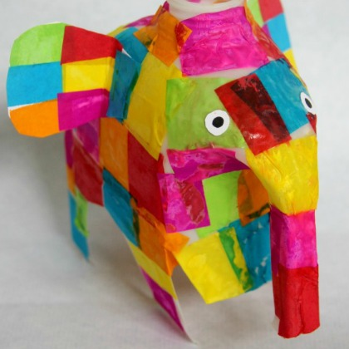

ELMER SAVES THE WORLD!

Length of Session
1.5 hours

Group Size
Full class or small groups

Aims
To offer a fun and informative session that enables children to develop their creativity, imagination and story-writing skills, whilst learning how to re-use their own waste materials as a resource for creative work.

Summary of Activity
Ask the children to bring a 2 litre plastic milk bottle to the session so that they can make the link between the ordinary materials at home they can reuse and recycle. (Make sure the bottles are rinsed thoroughly so they don’t get too smelly!)
The session starts with a short introduction on waste and how to reduce, reuse and recycle. The Teacher will then introduce the Elmer making activity, explaining how pupils will be reusing their own waste (plastic milk bottle) to make an Elmer, and going through the step by step instructions below.
When pupils have completed their Elmer, children can write a short story about how Elmer and his friends reduce, reuse and recycle. (See Elmer Saves the World! sheet below).

Learning Objectives
Children should learn:
- Materials which can be used in a variety of ways
- That some materials can be re-used or recycled rather than thrown away
- How to put their ideas into sentences
- How to use a clear structure to organise their writing

How to Make an Elmer
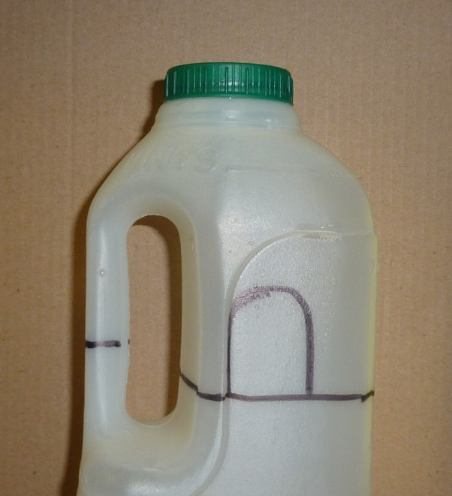
Resources
- Plastic milk bottle (2 litres)
- 2 Split pins or tape
- Scissors
- Tissue paper in a variety of colours
- PVA glue
- Paintbrush
- Water
- Jam jar

Method
- Cut the bottle in half as shown and make sure the base is flat
- Cut through the handle as shown to form the trunk
- Cut out an arch-shaped piece from each side and the back to make the legs (leave a tail). These pieces can become Elmer’s ears
- Shape the ears and attach with a split pin or tape
- Mix PVA glue with water in jam jar
- Cut small squares of coloured tissue paper and using paintbrush and glue solution, stick on one piece of tissue paper at a time to create the classic patchwork Elmer effect

There is a good pictorial guide here
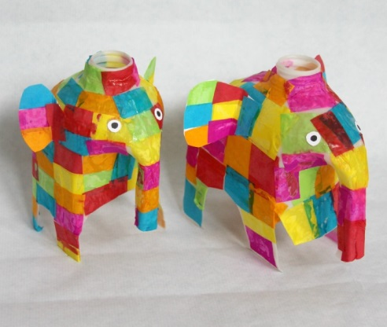

Elmer Saves The World!

Now you’ve re-used your waste and made a wonderful Elmer, you can make up your own story to show how Elmer helps to save the world! Think about what you’ve learned today and write a story about how Elmer and his friends reduce, reuse and recycle. Follow the story writing steps below:

A well planned story has a plot that develops from setting the scene at the beginning, through the action in the middle, and to the end where you tell your reader what happens to the characters, clear up any mysteries and tie up any loose ends.
The first thing to remember is that stories have a beginning, a middle, and an end. A story has to be in the right order or your readers won’t understand it.

- Beginning
The beginning of a story is where you introduce your readers to your style, setting and characters. Often a writer will give his characters a problem to solve. This keeps the reader interested, as they’ll want to find out what happens.

- Middle
In the middle you develop your story. The reader begins to ask more questions and starts to learn what will happen to the characters.
- End
In the end you tell readers exactly what happens to the characters and how they solved the problems you gave them at the start.
Don’t leave any questions unanswered at the end of the story and make sure your reader knows what happens to all your characters.
Remember - when you tell or write a story you can make anything happen. All you need is your imagination!

